PART 1 : Setting up the Lambda role.

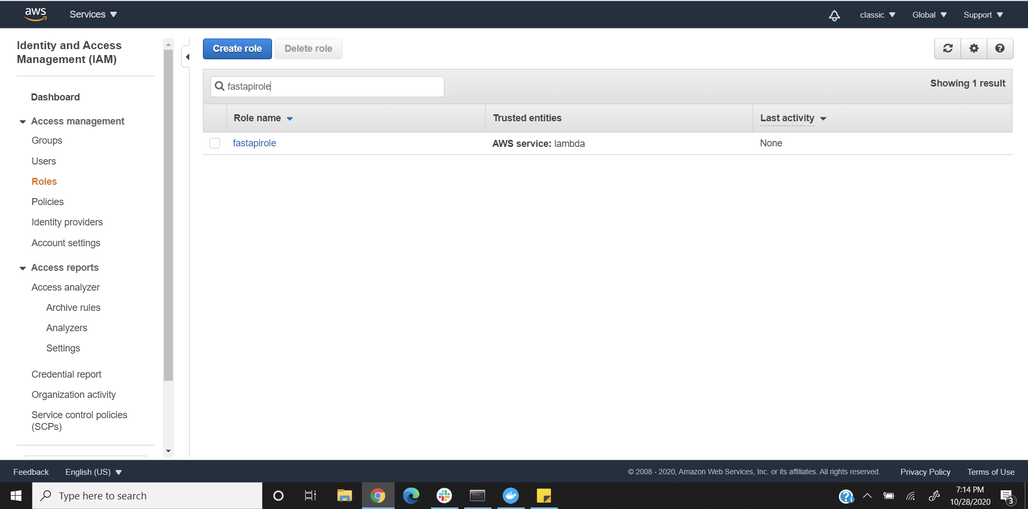

PART 2 : Setting up the Travis user.

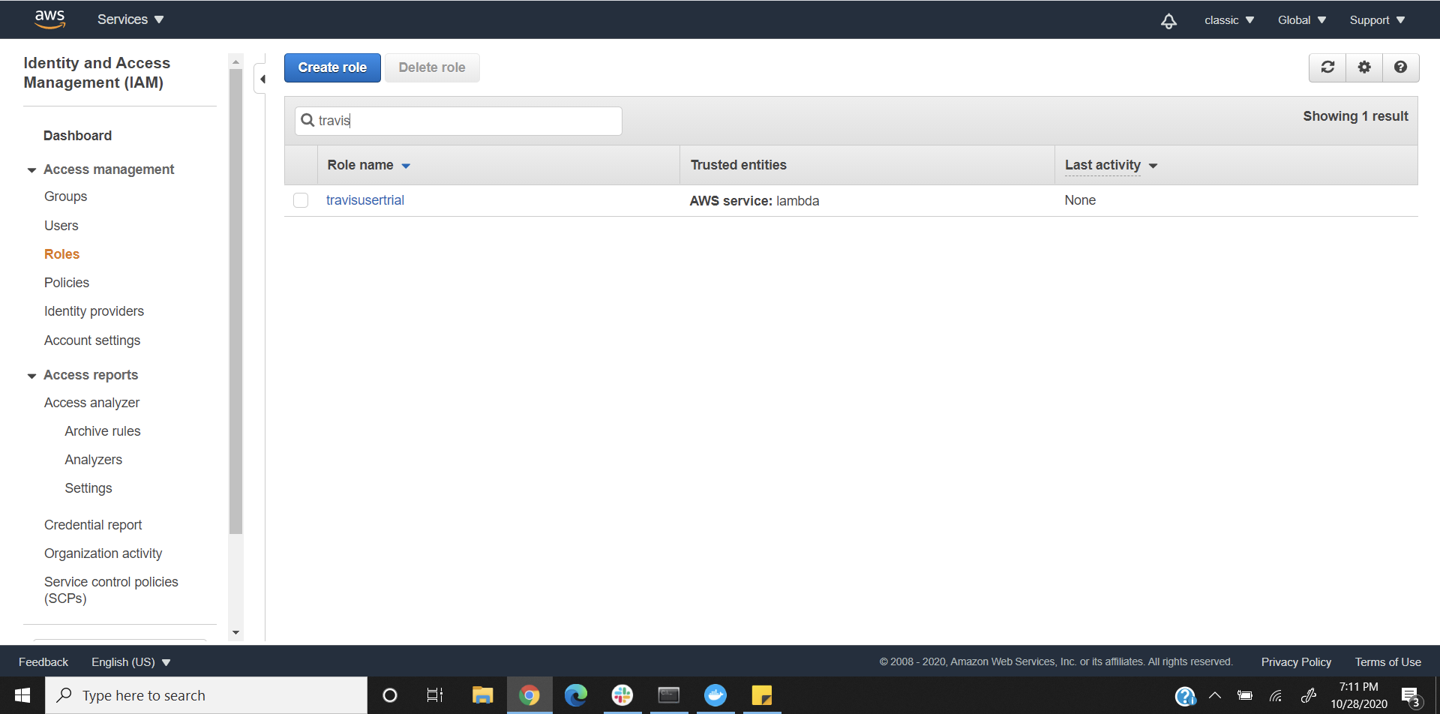

PART 3 : Setting up the Travis Deployment Bucket.

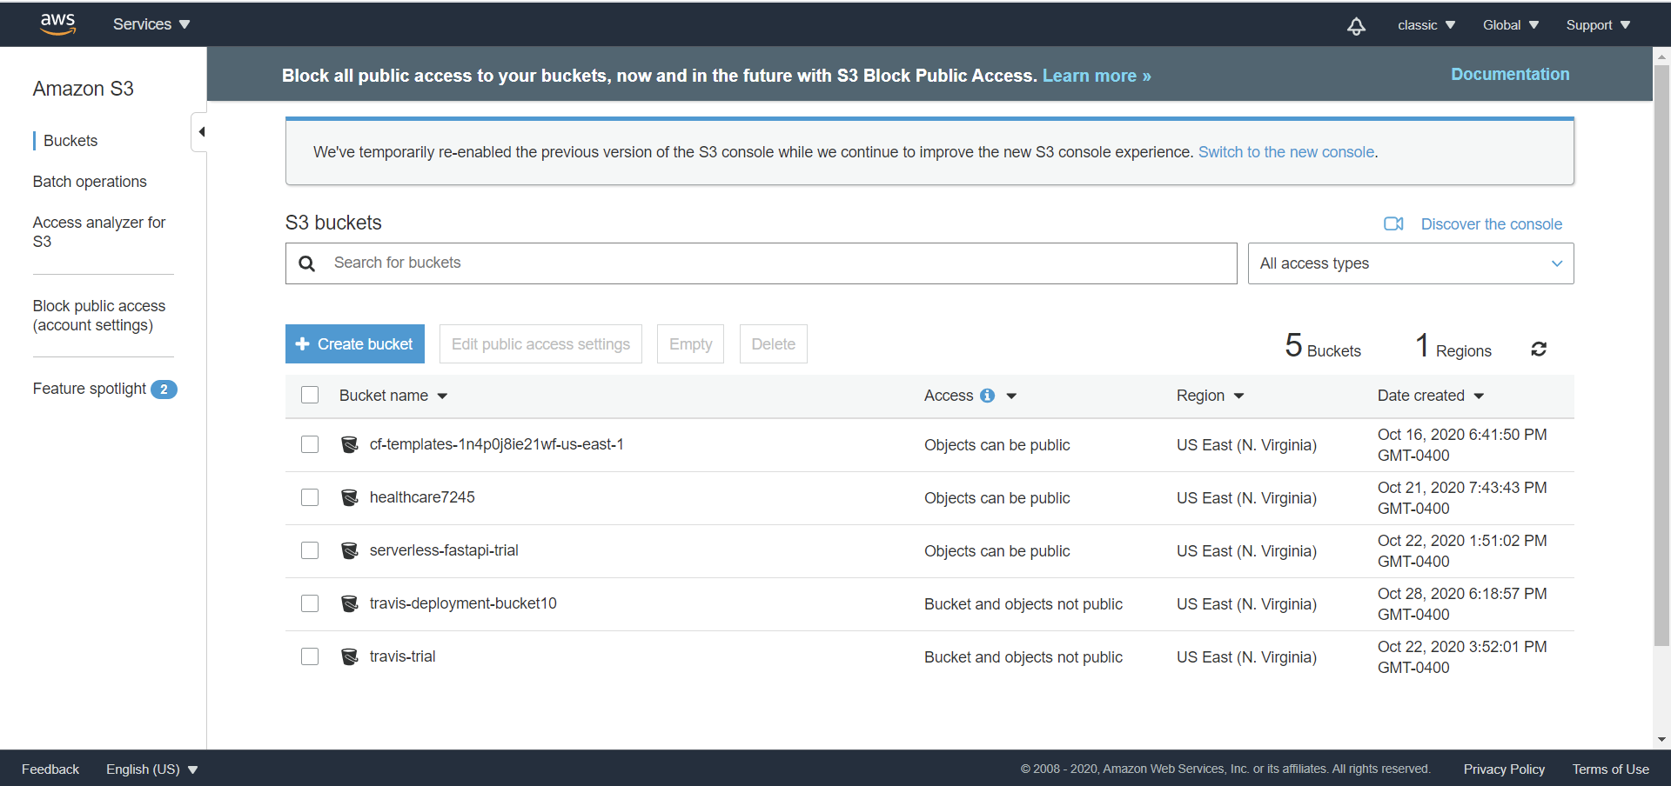

PART 4 : Build & Validate the AWS Sam Package.

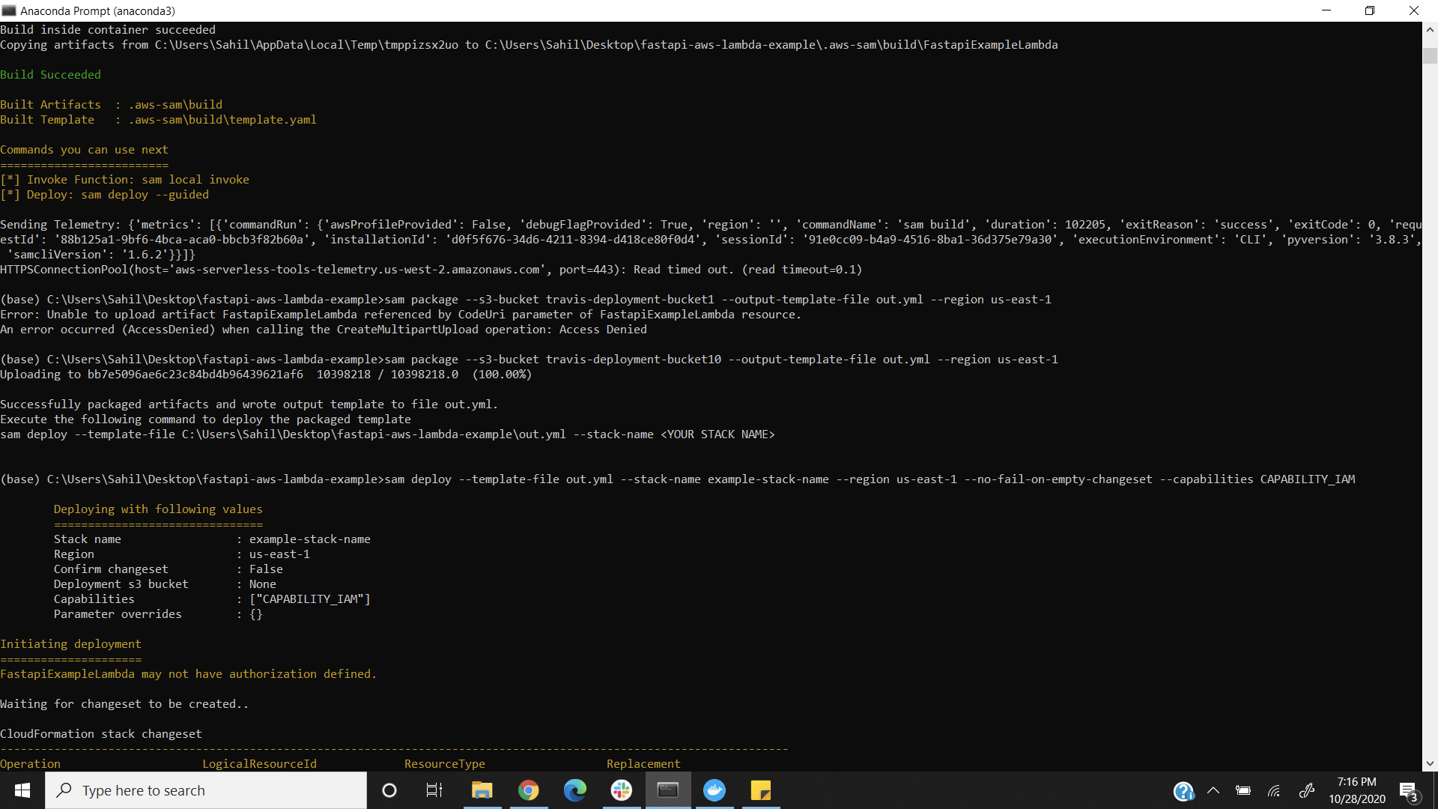

PART 5 : Deployment of Sam Package.

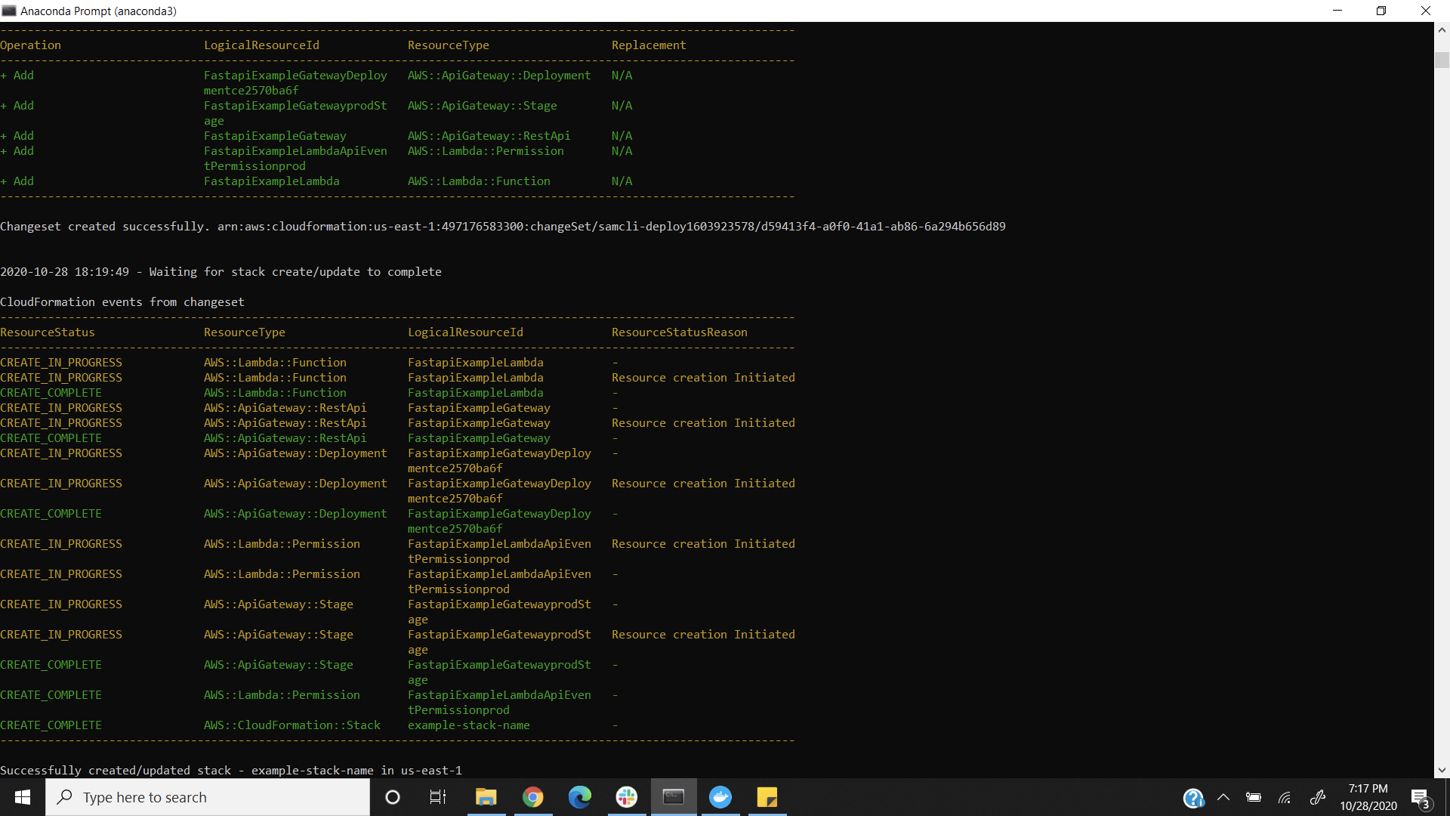

Part 6 : Deployed SAM Package into the S3 Bucket.

